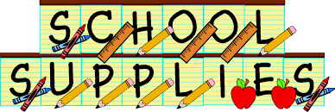

WELCOME TO FIRST GRADE!

You will need the following supplies
when you begin first grade:

- 2 boxes of 24 crayons
- 2 packs of 12 pencils
- 4 large erasers
- 4 large glue sticks
- plastic pencil box
- 3 two-pocket folders
- 2 boxes of tissues
- 1 pack of disinfecting wipes or baby wipes
- 1 box of sandwich size Ziploc bags (GIRLS ONLY)
- 1 box of gallon size Ziploc bags (BOYS ONLY)
- Backpack – NO WHEELS
- Healthy snack each day

Optional Supplies:
- 1 box of 8 washable markers
- 1 wide-ruled composition notebook

Personal items such as jackets, backpacks, and lunchboxes should be labeled with first and last name. Please NO personal pencil sharpeners. We have electric sharpeners in each classroom.

Thank you!

